I have replicated the classes from CustomerController, CustomerDAO and Customer. I have made all necessary adjustments to the new classes to make them work for the items.

I have also adjusted the sql-schema to create an item table as well as adding some values within the sql-data file

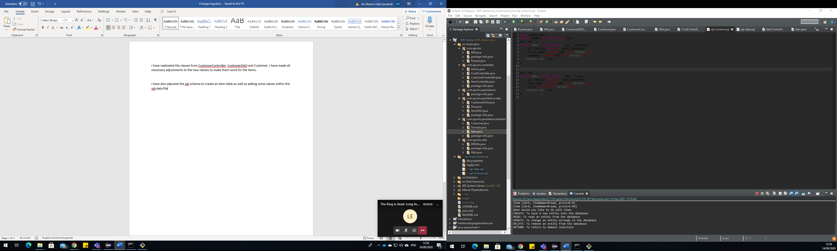

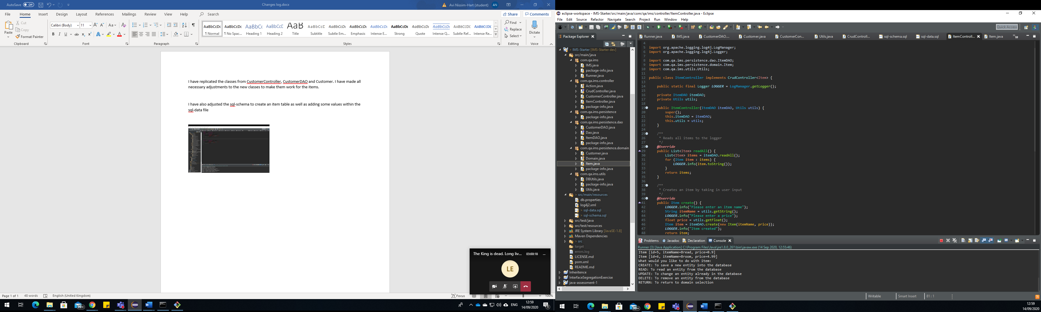

I have adjusted the sql-schema to create the orders table. First try, may make alterations soon

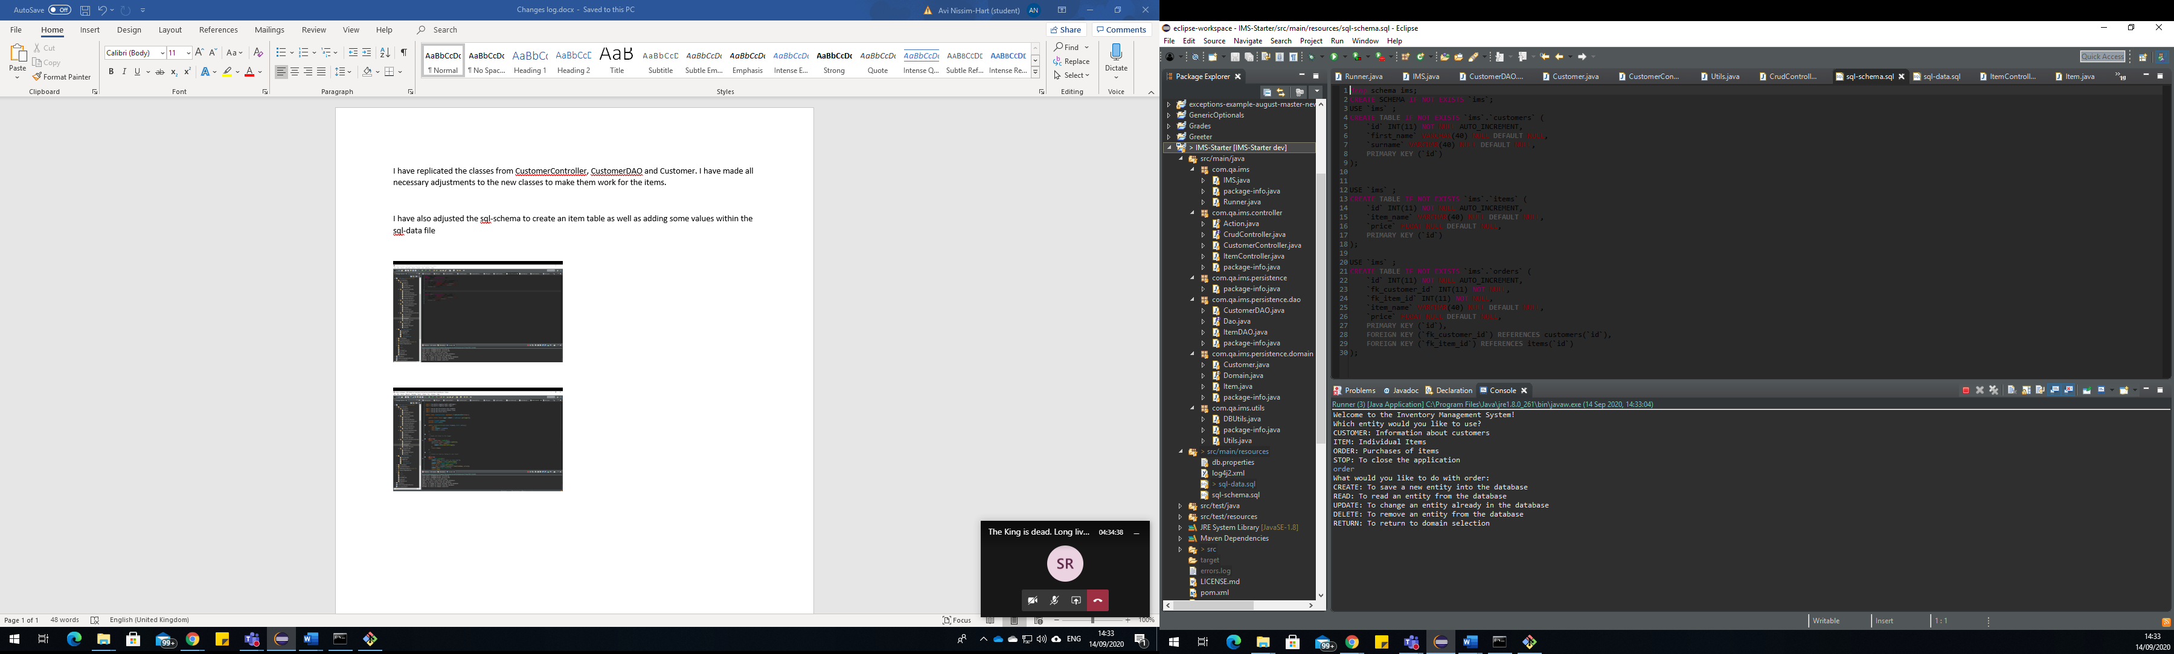

I have now made DAO classes and controller classes for the new tables and adjusted them so that it works properly for the moment. I am still yet to make all the major adjustments to make the orders work as desired.

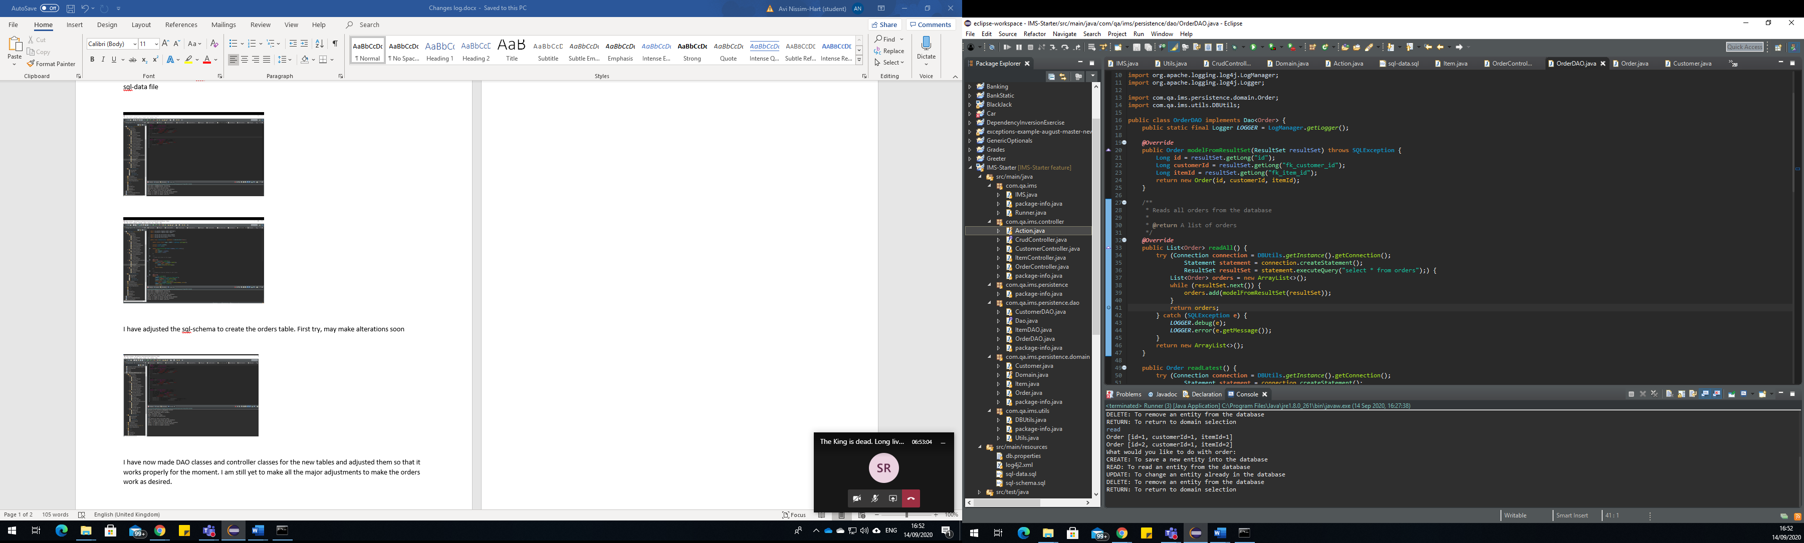

Here is my sprint board at the moment

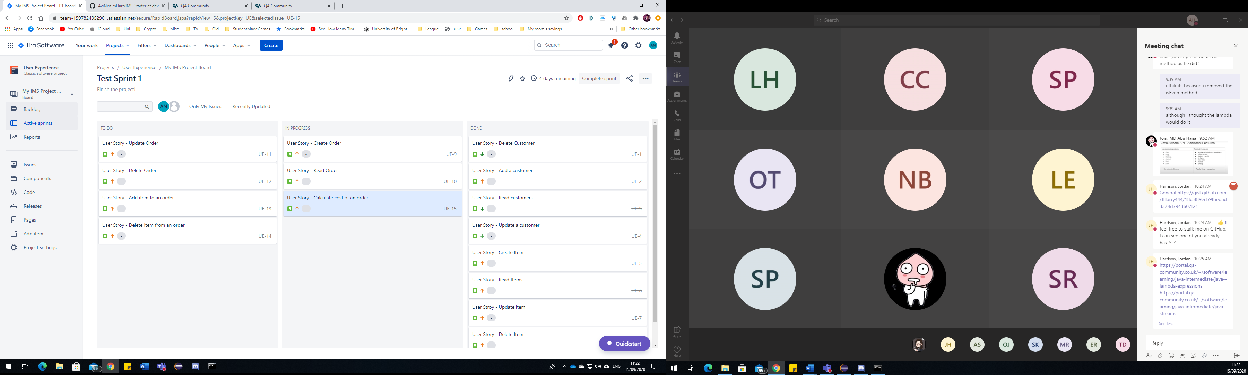

After a lot of blood sweat and tears, I finally implemented the addto and delfrom functions within the update order function. What took me the longest to figure out was that the order calculation should take place in this function. Figuring out the mysql statement to do this took a very long time as well. Despite this delay, I still got over this hurdle and am back on track! Although I am still making slight alterations.

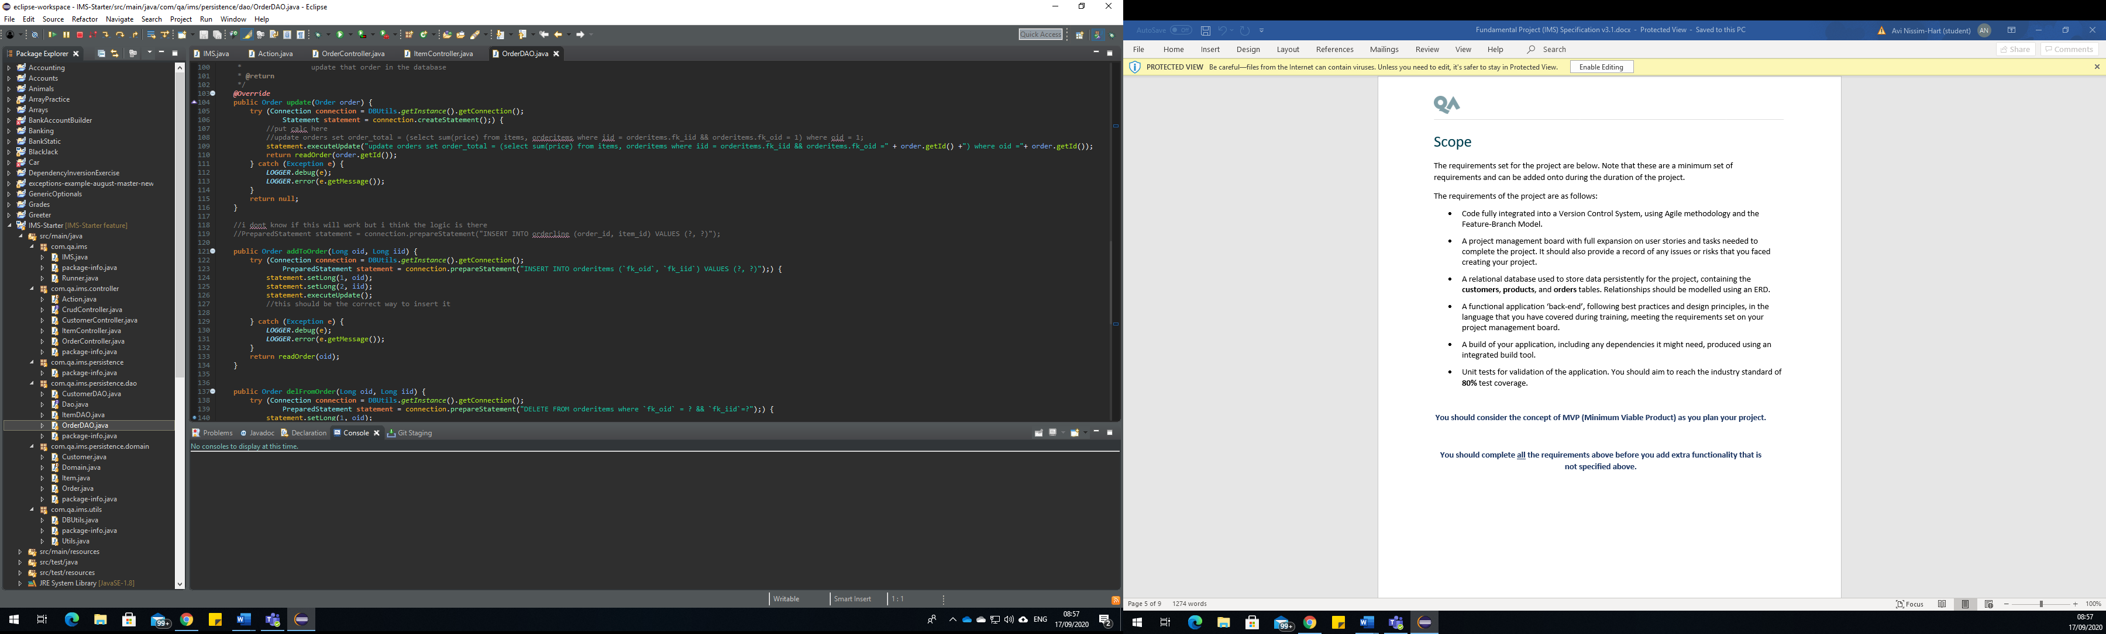

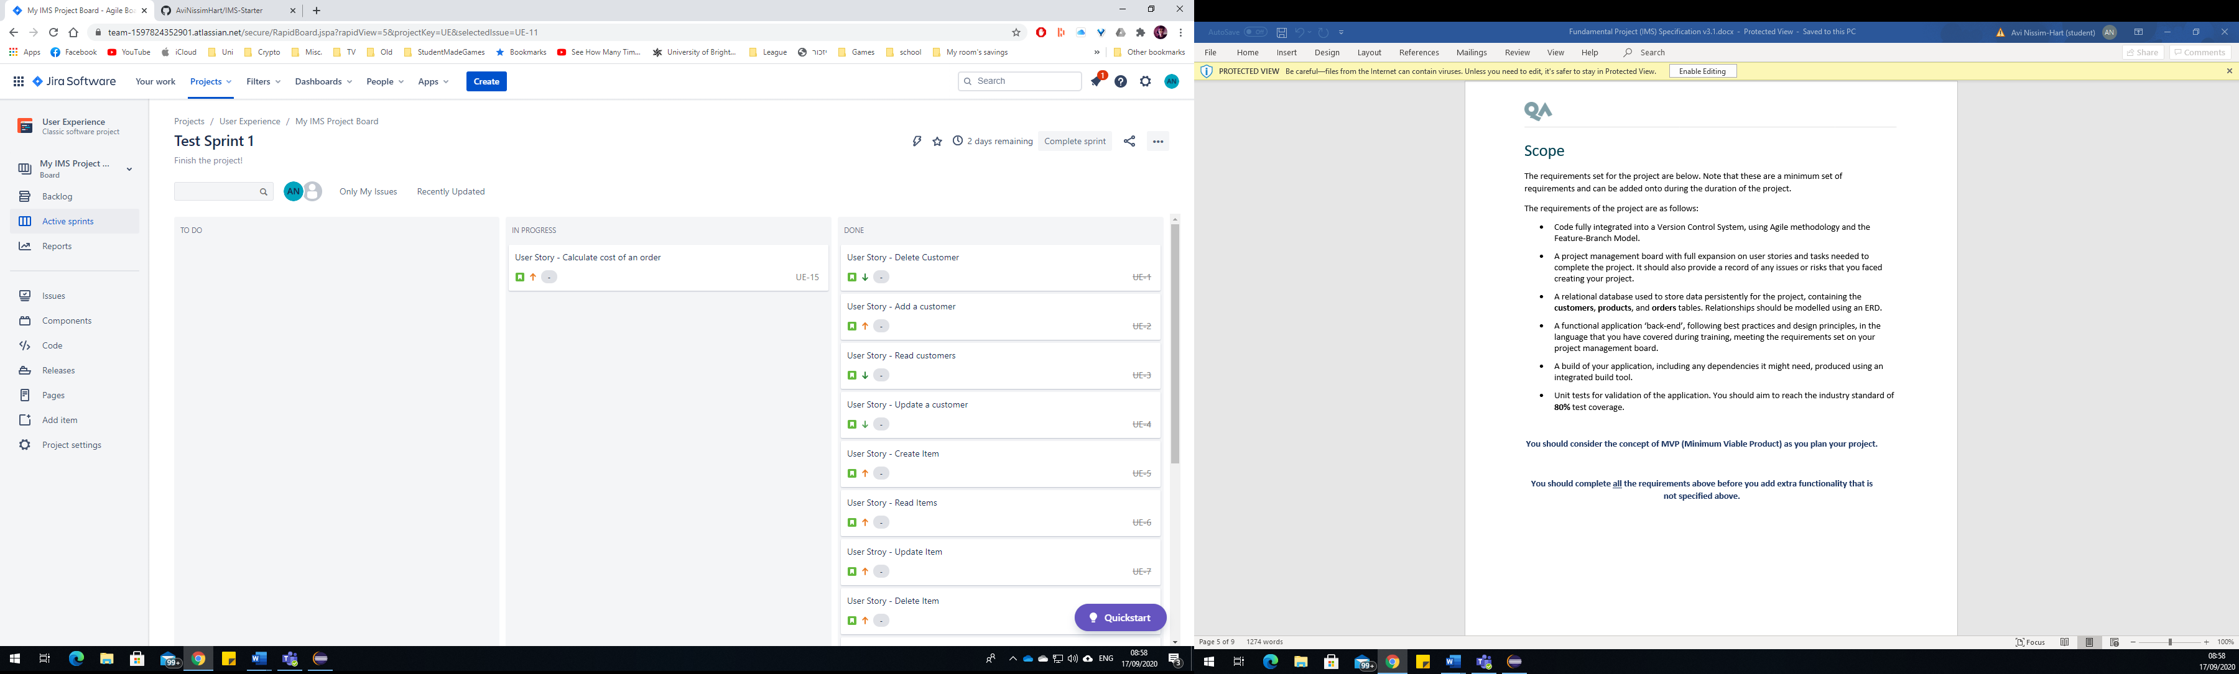

Finally finished making the code work properly to display items in orders.

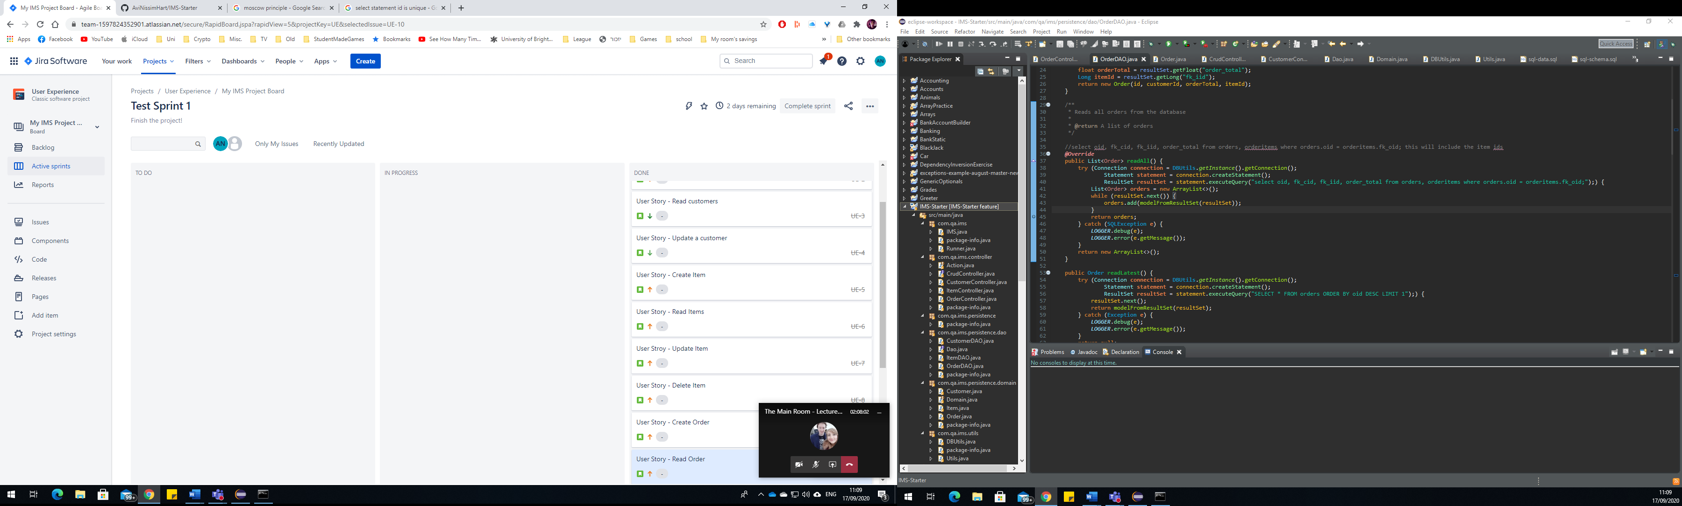

Now to begin testing!

Upon testing out all the functions, I discovered issues with deleting customers orders and items due to their foreign key constraints causing other tables to depend on them.

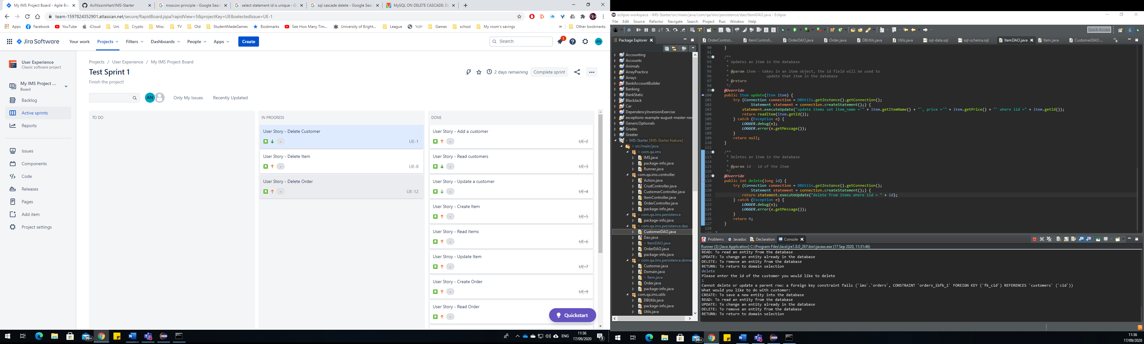

I must now go back and fix this. Possibly with cascade delete.

Fixed this pretty much.

Testing now

After making adjustments to the schema.sql file to drop all tables before making them again, I have gotten the customerDAO testing to work

